South County Art Association Instructor
Allie Hunt
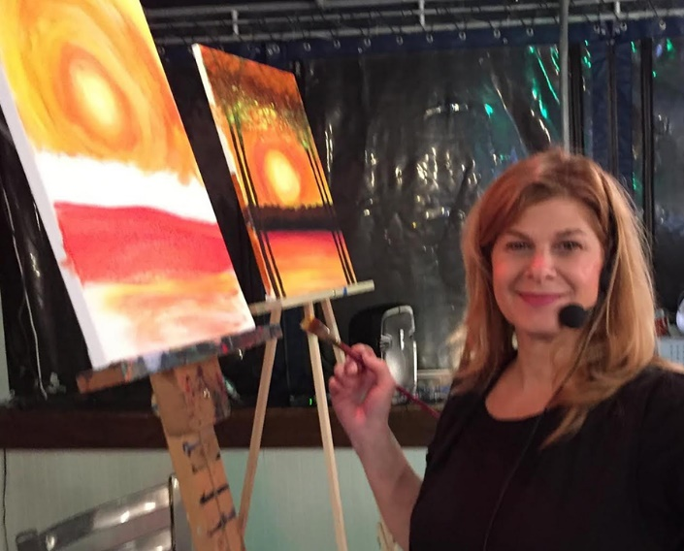

I developed an interest in art in early childhood, having been captivated by my father's creations as a professional sculptor. For as long as I can remember, I have enjoyed painting dramatic trees and landscapes in acrylic and watercolor. I graduated from The University of Rhode Island where I majored in Studio Art and Art History, and later earned an additional degree in education.

A longtime resident of Narragansett and Bonnet Shores, my featured Wine & Paint Night themes often have a local flair, such as lighthouses, bridges, beaches, and the Narragansett Towers. I created Wine & Paint Night, to provide a fun and spirited way for friends to enjoy time together while creating art and a great night out!!!

I've been part the community of artists at South County Art Association for over 5 years, where I have a studio which is a place of great joy and inspiration for me.

www.wineandpaintnight.com

